**Planning Services** IRF18/7103

Gateway determination report

|  |  |
| --- | --- |
| **PPA** | Orange City Council |
| **NAME** | Towac Park |
| **NUMBER** | PP_2018_ ORANG_001_00 |
| **LEP TO BE AMENDED** | Orange LEP 2011 |
| **ADDRESS** | Ploughmans Lane/Canobolas Road/James Road |
| **DESCRIPTION** | Area bounded by Ploughmans Lane, Canobolas Road, Pinnacle Road and west of Shiralee Road. Property description provided on page 3 of this report. |
| **RECEIVED** | 13 December 2018 |
| **FILE NO.** | IRF18/7103 |
| **POLITICAL DONATIONS** | There are no known donations or gifts to disclose and a political donation disclosure is not required, OR a political donation disclosure statement has been provided |
| **LOBBYIST CODE OF CONDUCT** | There have been no known meetings or communications with registered lobbyists with respect to this proposal |

**INTRODUCTION**

**Description of planning proposal**

It is proposed to rezone 58.5 ha of rural land zoned RU1 Primary Production to R5 Large lot residential, reduce the minimum lot size from 100ha to 2ha for the purpose of an ‘Equine Park’ adjacent to Towac Park racecourse in Orange.

**Site description**

The site is located in south west Orange at the edge of the urban area, as shown on Map 1. The total 68ha site is bounded by Canobolas Road, Ploughmans Lane and Pinnacle Road, with the southern boundary being a virtual extension of Shiralee Road west. James Road is unformed and is part of the site. The site is made up of land zoned R5 Large Lot Residential (9ha) and RU1 Primary Production (58.5ha). Towac Park racecourse sits to the north east of the ‘L’ shaped site. To the north Canobolas Road and the Orange Broken Hill railway line extends east-west, and to the north of this is full residential development and the Wentworth Golf club. To the west of the site is rural land used for a range of commercial agricultural and semi-rural development. The subject area currently consists of 15 parcels ranging in lot sizes from 0.9ha to 16.7ha mostly with dwellings located thereon.

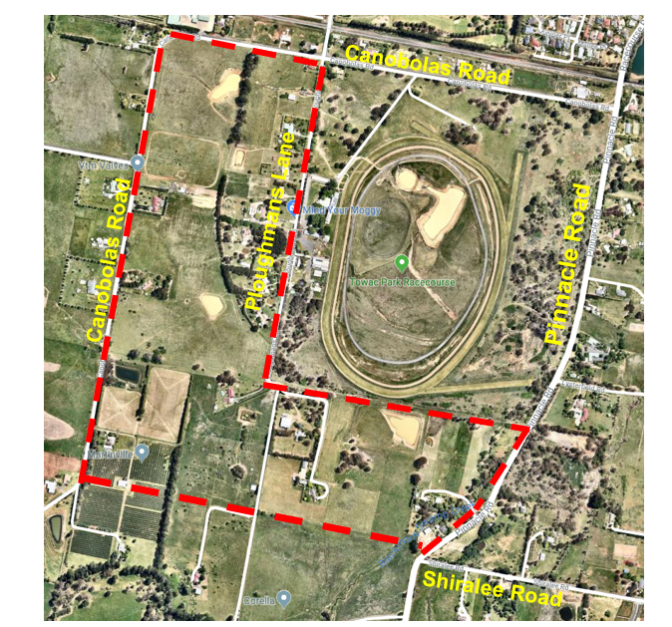

Map 1 – Boundaries of the subject land

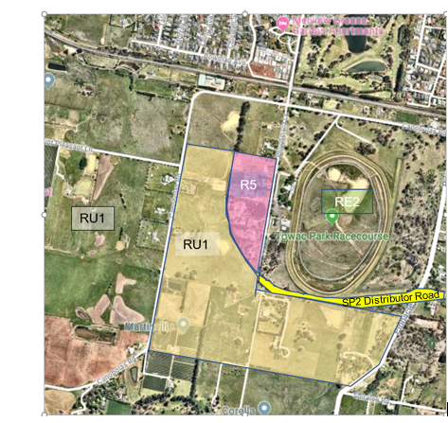

Map 2 – Land use zones and location near Towac Park racecourse

SP2 Distributor Road

The total area of land the subject of the proposal is approximately 68ha. The proposal includes a dissection of properties in the southern part of the locality, corresponding with an extension of the Shiralee Road alignment.

Area of Land zoned RU1 Primary Production:

|  |  |  |
| --- | --- | --- |
| **Address** | **Real property address** | **Area** |
| 113 Canobolas Road | Lot 11 DP 700977 | 16.7ha |
| 24 Canobolas Road | Part Lot 2 DP 615542 | 8.5ha |
| 77 James Road | Lot 14 DP 785177 | 0.9ha |
| 5 Ploughmans Lane | Part Lot 15 DP 785177 | 8.2ha |
| 16 James Road | Lot 16 DP 846647 | 2.2ha |
| 1 Ploughmans Lane | Lot 17 DP 846647 | 13.2ha |
| 35 Pinnacle Road | Lot 1 DP 310521 | 5ha |
| 136 Pinnacle Road | Lot 192 & Lot 144 DP 750401 | 0.33ha & 1.1ha |
| Roads | | 0.19ha, 0.8ha, 1.3ha |
|  | **TOTAL AREA RU1:** | **Approx. 58.5ha** |

Land zoned R5 Large Lot Residential:

|  |  |  |
| --- | --- | --- |
| **Address** | **Real property address** | **Area** |
| 57 Ploughmans Lane | Lot 10 DP 700977 | 1.7ha |
| 53 Ploughmans Lane | Lot 9 DP 700977 | 1.4ha |
| 45 Ploughmans Lane | Lot 8 DP 700977 | 1.3ha |
| 39 Ploughmans Lane | Lot 7 DP 700977 | 1.3ha |
| 35 Ploughmans Lane | Lot 6 DP 700977 | 1.1ha |
| 27 Ploughmans Lane | Lot 5 DP 700977 | 0.9ha |
| 17 Ploughmans Lane | Lot 4 DP 700977 | 0.9ha |
|  | **Total R5** | **8.6 ha** |
| **Total RU1 and R5 land** |  | **Approx. 68ha** |

**Existing planning controls**

The site is zoned a combination of R5 Large Lot Residential and RU1 Primary Production. The current minimum lot size for each is 2ha and 100ha respectively.

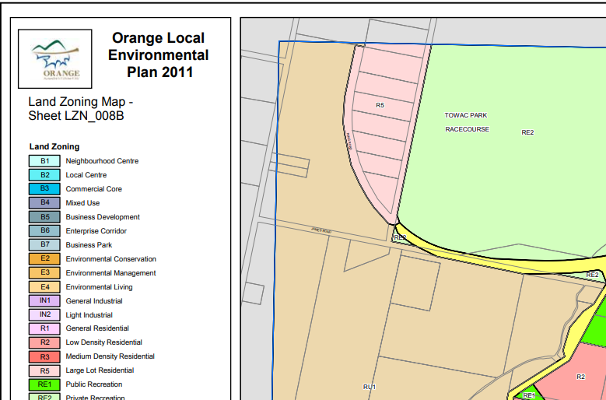

Land use zones: Excerpt from OLEP 2011 Sheet LZN_008B

**Surrounding area**

The subject area is located to the west and south of the Towac Park racetrack on the urban ‘fringe’ of Orange. The area is comprised of small lots used for a combination of horticulture and lifestyle development. The recent ‘Shiralee’ development is east of the subject site over Pinnacle Road, being a substantial residential subdivision with lot sizes ranging from 200-7000m², see excerpt from OLEP 2011 Sheet LSZ_008B below.

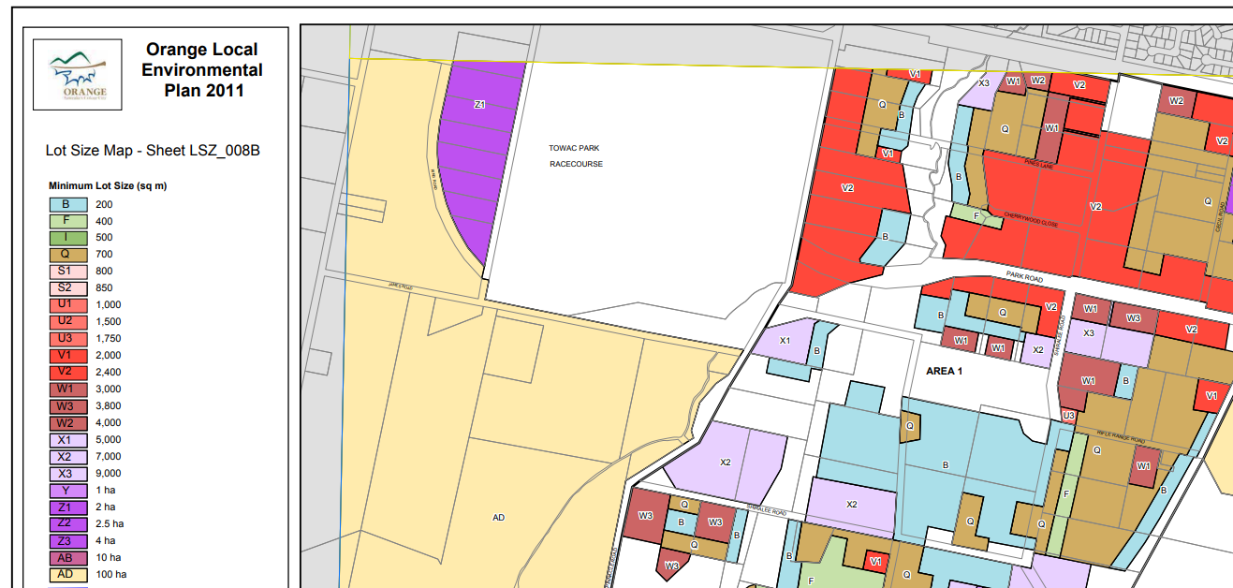

.

**Summary of recommendation**

The proposal’s merit is connected the site’s inclusion in ‘Living Area 9’; part of the Department endorsed (29/07/2011) Orange Sustainable Settlement Strategy (OSSS) which identifies the land as a long term residential precinct. It is proposed to rezone rural land to large lot residential and reduce the100ha minimum lot size to 2ha to facilitate development for an ‘equine park’. An ‘equine precinct’ is based on the proximity to Towac Park Racecourse and with this theme will rely on a local planning mechanism and Council compliance.

Due to the need for more information on several key planning issues, the recommendation will be to proceed with conditions as follows:

* consultation with government agencies before exhibition to review the extent of the area affected by the rezoning, particularly the interface with agricultural land;
* assessment of contamination, water resources, flora and fauna;
* assessment of impact on current and future traffic movements;
* a review optimal lot sizes (water supply and sewer disposal) and extent of the proposal after receiving agency advice; and
* use of a site specific LEP clause as a means of limiting development and protecting other land zoned R5. This approach is supported by Council.

The reason for this approach is that the proposal is in an area that needs more comprehensive strategic analysis and the proposal can be supported in the interim based on the proposed larger minimum lot size and proximity to Towac Park. It is to be recommended that Council not receive plan making delegation at this time until further work is undertaken to address inconsistencies with section 9.1 Directions and servicing.

It is also noted that Council is undertaking a review of its land use strategies that will help inform the best use of this and nearby important agricultural land.

**PROPOSAL**

**Objectives or intended outcomes**

It is proposed to create a specialist ‘equine precinct’ adjacent to the Towac Park racecourse *‘that encourages the establishment of rural residential holdings in support of training, breeding and horse management’*.

The idea for an ‘equine precinct’ that links to the Towac Park Racecourse is not justification for reducing minimum lot size of rural land from 100ha to 2ha in itself. ‘Animal boarding and training establishments’ are already permissible in both land use zones that make up the subject site.

Based on the dated OSSS this area is identified for future urban use in the long term with the proposal a mechanism to achieve some interim opportunity until up to date strategic planning is undertaken.

**Explanation of provisions**

Several options for amending provisions have been provided, with the preferred approach yet to be settled but likely to be a R5 zone and dedicated clause for the area. Council agree with this approach.

**Mapping**

The mapping provided indicates the subject land.

After agency consultation the proposed maps may need to be updated before the exhibition of the proposal.

**NEED FOR THE PLANNING PROPOSAL**

A planning proposal is the best way of achieving the desired outcomes.

**STRATEGIC ASSESSMENT**

**Regional**

The planning proposal considers alignment with a number of Directions and Actions from the Central West and Orana Regional Plan 2036, as follows:

* **Direction 4 – Promote and Diversify regional tourism markets** – where it is argued that the proposal supports tourism markets ‘promoting a mix of equine events…’ as the precinct is identifiable and marketable consistent with regional tourism objectives.

*Department comment*: the proposal to subdivide into lifestyle holdings with an ‘equine’ theme does not in itself have a direct relationship or bearing on tourism outcomes. The proposal may assist and support Towac Park as an “equine” facility.

* **Direction 6 - Expand education and training opportunities** – it is suggested by the applicant that a designated equine precinct will have the effect of promoting educational opportunities through TAFE and universities.

*Department comment*: while Towac racecourse could be and may already be used for education and training opportunities, the proposal has limited relationship with the proposal to subdivide land nearby for large lot residential development. Compliance with the “equine” theme will be a Council matter.

* **Direction 12 – plan for greater land use compatibility** 
  + Action 12.2 Identify and protect important agricultural land in local plans
  + Action 12.3 Create local strategies to limit urban and rural housing development in agricultural and extractive resource areas, industrial areas and transport corridors.
  + Action 12.4 Amend planning controls to deliver greater certainty of land use
  + Action 12.5 Provide non-statutory guidance on appropriate and sympathetic land use in areas where land use conflicts occur.

*Department comment*: The proposal is inconsistent with Actions 12.2 and 12.3 and potentially consistent with 12.4 and 12.5. In terms of 12.2 at this time the OSSS indicates, that in the long term, the land is suitable for future residential use. This strategy is being reviewed as there is important agricultural land on this site and nearby. In terms of 12.3, it is acknowledged that a comprehensive review of Orange’s planning strategies is currently underway. Further to 12.4 it will be necessary to prepare appropriate LEP provision(s) to control the impact of the proposal on surrounding land until further strategic work is completed.

* **Direction 28: Manage rural residential development.**
  + Action 28.1: locate new rural residential areas close to existing settlements to maximise the efficient use of existing infrastructure and services, including roads, water, sewer and waste services and social and community infrastructure;
  + Action 28.2: enable new residential development only where it has been identified in a local housing strategy
  + Action 28.3: manage land use conflict that can result from cumulative impacts of successive development decisions.

*Department comment*: consultation is being recommended with agencies to assist in determining sustainable water and sewer requirements. While the land is in a long term strategic area recognised by the OSSS, the proposal does not address potential for land use conflict with adjoining rural land at this time.

**Local**

The Orange Sustainable Settlement Strategy (OSSS) (2004, with 2010 update) identifies the site as part of ‘Land Unit 9’, which is a long term residential precinct. However, LU9 was identified in the strategy as not being required for the life of the plan, which would be 2024. The 2010 update was prepared in response to the rezoning of land and development of the Orange Base Hospital at Bloomfield by the government, which changed infrastructure planning and delivery for Council by adding a push to the south of Orange as well as north Orange. Land to the south of Orange has historically been identified as part of the drinking water catchment and therefore not compatible with future residential development on a large scale.

The OSSS is to be reviewed in 2019 and the Blayney Cabonne Orange Rural and Industrial Lands Strategy 2008 is currently being reviewed. Both documents will need to focus on the subject land in terms of its future as a peripheral area between full residential and productive agricultural land towards Mt Canobolas. The identification of the land by the OSSS allows it to be considered in terms of consistency with Section 9.1 Directions.

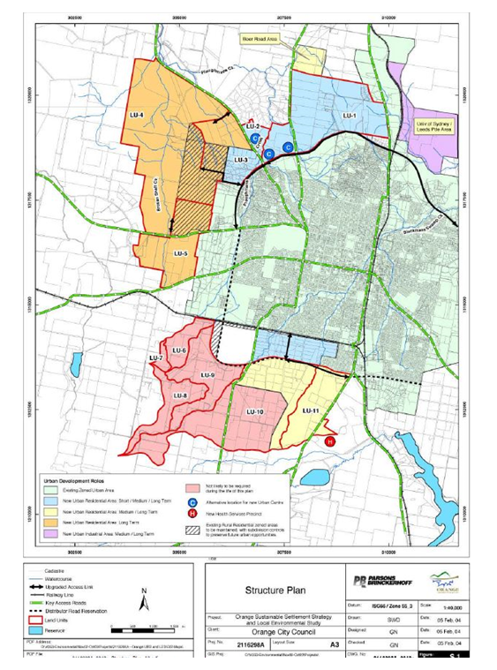

Extract from Orange Sustainable Settlement Strategy showing Land Unit 9, with the subject land.

**Section 9.1 Ministerial Directions**

As noted, the proposal is located within Land Unit 9, which is a long term residential option as part of the endorsed Orange Sustainable Settlement Strategy (OSSS). Land Units 9-11 were regarded as ‘excess’ areas should Orange’s population growth exceed the expected rate. It is likely that the subject area will be the focus of more detailed master planning in terms of the transition between urban and rural land uses. The relevant Section 9.1 Directions are as follows:

**Directions 1.2 Rural Zones** is applicable as it is proposed to rezone rural land to residential. The endorsed OSSS identifies the land for future long term residential. Direction 1.2 is applicable to the planning proposal and states the loss of rural land will be small and the ‘associated promotion of horse grazing, recreation and training are rural associated industries’. While the loss of approximately 60ha of rural land could be deemed relatively minor, there is an inconsistency at this time and consultation with DPI required to assist in resolution. These relate to there being planning justification for small lot subdivision, precedent, the flow on impacts of the proposal on surrounding and adjoining rural activities, enforceability of an ‘equine precinct’, equity considerations and potential for land use conflict.

At this time the proposal is inconsistent with this Direction and consultation with agencies and further work is required before community consultation to resolve this matter.

**Direction 1.3 Mining, Petroleum Production and Extractive Industries** is applicable as the proposed rezoning to residential will prohibit or restrict mining. The proposal assumes that it would be unlikely that a mining or quarry proposal would be able to achieve environmental compliance in such a developed locality.

At this time the proposal is inconsistent with this Direction and consultation with Resources is required before community consultation to address this matter.

**Direction 1.5** **Rural Land** is applicable as it is proposed to rezone rural land and deals with changes to rural minimum lot sizes and is relevant to the proposal. The planning proposal suggests that the loss of rural land is minimal and further that an equine estate is compatible with the ‘highly settled’ nature of the locality. There is an orchard on Lot 2 DP 615542, 259 Canobolas Road that requires consideration. ‘Martinville’ is also a noted historic 1890’s orchard in Orange.

At this time the proposal is inconsistent with this Direction and consultation with agencies is required before community consultation to address this matter.

**Direction 2.3 –Heritage conservation** is applicable as there several heritage items near the proposal. The planning proposal suggests that the only heritage items are the Towac Park grandstand. There are no heritage items identified in the locality by the proposal although the OLEP Heritage Schedule indicates there are a number of heritage items nearby on Canobolas Road, Spurway Lane, Pinnacle Road, Mt Pleasant Lane and Shiralee Road. The advice of the Office of Environment and Heritage (OEH) should be sought in relation to impacts on heritage.

At this time the proposal is inconsistent with this Direction and consultation with OEH is required before community consultation to address this matter.

**Direction 3.1 Residential** **zones** is applicable as it is proposed to rezone the land to residential – the proposal indicates consistency with this Direction based on the justification provided by the Orange Sustainable Settlement Strategy (OSSS). However, the Direction states that land must be adequately serviced before it is developed. The proposal intends not extending any services to the subject land. There is a disconnect between the strategic justification for the site (for full residential by the OSSS) and the form of development being proposed (rural residential).

At this time the proposal is inconsistent with this Direction and consultation with agencies is required before community consultation to address this matter.

**Direction 3.4 Integrating Land Use and Transport** is applicable as it is proposed to create a residential zone. At this time the proposal is inconsistent with this Direction and consultation with agencies is required before community consultation to address this matter.

**Direction 4.3 – Flood Prone Land –** is not relevant as the proposal notes that the land is not floodprone.

**Direction 4.4 Planning for bushfire protection** – there is no advice regarding the bushfire risk of the land.

At this time the proposal is inconsistent with this Direction and consultation with NSW RFS is required before community consultation.

**Direction 5.10 Implementation of Regional Plans** – generally inconsistent as discussed previously. Consistency with an endorsed strategy assists this proposal, and the scheduled review of the area in two land use strategies is also beneficial. At this time the proposal is inconsistent with this Direction and consultation with NSW RFS is required before community consultation to address this matter.

**Direction 6.3 Site Specific Provisions** is relevant as Council has agreed to a site specific provisions to allow this proposal to progress. It is identified that it is necessary to introduce an interim site-specific provision in order to manage the proposal while strategic work is being undertaken. This is an initiative of the Department with the agreement of Council that is justified given the nature of the proposal.

At this time the proposal is inconsistent with this Direction and consultation with agencies is required before community consultation to address this matter.

**State Environmental Planning Policies (SEPPs)**

State Environmental Planning Policy (Rural Lands) 2008 is applicable to the land zoned RU1. The SEPP sets out considerations for the ‘orderly and economic use and development of rural lands for rural and related purposes’, to ‘implement measures to reduce land use conflicts’ and introduce principles to assist ‘the proper management, development and protection of rural lands for promoting the social, economic and environmental welfare of the State’.

The proposal suggests consistency with the SEPP due to ‘minimal’ loss of agricultural land to large lot residential development.

However, there is a need for more detailed analysis of the site, locality and particularly existing agricultural activities; consideration of the potential for rural land use conflict and the need to minimise rural land fragmentation with consultation with DPI - Agriculture.

This is necessary as the OSSS, while an endorsed Strategy for the purposes of the 9.1 Directions, deems the land as not required for future residential until at least 2024. Further there is substantial strategic review of rural land currently in progress.

SEPP No 55 – Remediation of land requires further work prior to the proposal progressing the community consultation.

**SITE-SPECIFIC ASSESSMENT**

**Social**

There are no identifiable social impacts as the result of the proposal.

**Environmental**

Environmental assessment has been nominal in support of this proposal. Contamination is required to be addressed. Water resources and flora and fauna are not assessed. Further consultation with agencies is recommended prior to the proposal proceeding to exhibition as a result.

# Economic

Generally economic impacts can be expected to be positive for Orange. The proposed servicing requirements will be required to be addressed. Towac Park Racecourse may also be attractive to the future land owners in this area.

**CONSULTATION**

**Community**

A 28-day consultation period is proposed, and this is appropriate in the circumstances.

**Agencies**

Council has not offered a view on the agencies to be consulted. It will be recommended that the following agencies are consulted:

* NSW Office of Environment and Heritage
* EPA
* Roads and Maritime Service
* Department of Primary Industries – Agriculture
* NSW Rural Fire Service
* DPE – Resources and Geoscience
* DoI - Water

**TIME FRAME**

A 12-month timeframe is appropriate for this proposal, given the recommended requirements for consultation and non-delegated authority.

**LOCAL PLAN-MAKING AUTHORITY**

Council has not requested delegations for this proposal. It will be recommended that Council not be granted delegation, at this time, to allow Council to undertake further work prior to proceeding to community consultation. This can be reassessed at that time.

**CONCLUSION**

Preparation of the planning proposal is supported to proceed with conditions.

**RECOMMENDATION**

It is recommended that the delegate of the Secretary:

1. note that the inconsistency with Section 9.1 Directions 1.2 Rural Zones, 3.1 Residential Zones and 5.10 Implementation of Regional Plans, is unresolved and will require justification.

It is recommended that the delegate of the Minister determine that the planning proposal should proceed subject to the following conditions:

1. Consultation is required with the following public authorities:

* Department of Primary Industries – Agriculture
* DPE – Resources
* Environment Protection Authority
* Office of Environment and Heritage
* DoI - Water
* Roads and Maritime Service
* Rural Fire Service

1. That, following receipt of advice from government agencies, Council is to provide a summary of submissions and meet with the Department to clarify the extent of the planning proposal and resolve inconsistency with the Section 9.1 Directions and SEPP’s. Council is to seek DPE approval prior to proceeding to community consultation.
2. Following endorsement by the Department, the planning proposal should be made available for community consultation for a minimum of 28 days.
3. Final maps to be compliant with DPE guidelines.
4. The time frame for completing the LEP is to be 12 months from the date of the Gateway determination.
5. Given the nature of the planning proposal, Council should not be authorised to be the local plan-making authority, at this time to make this plan.

**Wayne Garnsey Damien Pfeiffer**

**Team Leader, Western Director Regions, Western**

**Planning Services**

Assessment officer: Nita Scott

Senior Planner, Western Region

Phone: 5852 6800